 | Journal of Instructional Science and Technology  ISSN: 1324-0781  Editors-in-Chief: Olugbemiro JEGEDE (jegede@ouhk.edu.hk) and Som NAIDU (s.naidu@meu.unimelb.edu.au)

Volume 1 No 2, March 1996
- - - Article 1 - - -

Enriching Computer-Mediated Group Learning
by Coupling Constructivism with Collaborative Learning
by
W. R. Klemm and J. R. Snell
Department of Veterinary Anatomy & Public Health
Texas A & M University
College Station, TX 77843
Return to Contents Page

[ Abstract | Introduction | Constructivism | Logic Structures in a Bulletin Board Environment | Hypertext-based Conferencing | Collaborative Learning | Collaborative Learning Theory | Schedule Considerations | Grading | Conclusion | References ]

Abstract
Group learning can be a powerful educational experience, whether in distance or on-site education. However, group learning is often trivialised by the threaded-topic discussion format that is typically used in computer conference systems. Teachers can lead a group to raise the intellectual level of group discourse by requiring student groups to produce tangible work products (not just opinion comments) and by creating a logical structure to achieve this end. Secondly, the teacher's efforts can be leveraged by promoting interdependent student teams in which students help each other to produce the academic deliverables.

Introduction
Electronic mail and computer conference software provide a way for groups of students to learn. As usually practiced, learning takes the form of "discussions" among several or more participants. Commonly, many students "lurk" in the background without making contributions. Our experience in teaching four college courses and monitoring three others in a computer conference environment convinces us that such discussions are not very rigorous and that the quality of instruction suffers unless the teacher takes special care to create a more challenging learning environment. We have learned that instruction can become much more effective if students are required to DO something instead of just talk about it and to work together as a team to produce academic deliverables. In short, we advocate coupling constructivism with collaborative learning in computer conference environments.
Constructivism is promoted by defining what deliverables are expected and structuring the conference discourse with a logic structure that guides and focuses the group to produce academic deliverables. Collaborative learning is promoted by conferencing incentive systems that make the group members interdependent and by having specific roles in the conference for each student.
Electronic mail and computer conference software provide a way to generate dynamically evolving information bases for shared learning. The information base develops as an outgrowth of "discussions" among several or more participants. But the quality of those information bases suffers without careful consideration of how the bases are organized and the processes by which they are created.
We have experience, both as contributors and "lurkers," with several Listservs that are dedicated primarily to education (AEDNET, AACU96-L, DEOS-L, IATFORUM, ICTE-L, IPCT-L, STLHE-L, TCC-L, and WWWDEV). Each Listserv is a "threaded-topic" discussion environment, which is the model for using asynchronous computer conferencing in teaching. Typical asynchronous computer conferencing products (Caucus, Collabra Share, First Class, Lotus Notes, Meeting Room, Meeting Works, Open Mind, Team Talk, VAX Notes, Web Caucus, and others) use the threaded-topic discussion format, but extend it beyond ordinary e-mail by keeping a variety of topics active at the same time, with all past comments always accessible. There may also be ancillary features such as access controls and search capabilities.
What these systems lack, in our experience, is good support for implementing two fundamental pedagogical concepts: constructivism and collaborative learning. Constructivism (Duffy and Jonasson, 1992; Brooks, 1993; Tobin, 1993) is the idea that a student is an active learner who constructs a personal base of knowledge and understanding. In other words, the student does more than just "discuss" a topic. The student actually DOES something: that is, creates a product for delivery to the teacher, classmates, or others. Requiring students to do something not only provides the opportunity to create something that might be useful to others, but also presumably increases the depth of learning by the student who produces the deliverable. We learn best by doing.
Collaborative learning (Damon, 1984; Gabbert et al. 1986; Johnson and Johnson, 1989; Johnson et al. 1991; Kadell and Keehner, 1994; Kaye, 1991; Klemm, 1994; Webb, 1982) is the idea that small, interdependent groups of students work together as a team to help each other learn. As such, they leverage the efforts of the teacher. However, collaborative learning is seldom applied in a computer conferencing software environment, because the threaded-discussion systems do not expedite team building and effective group processes.
We think that educators who use computers in education are missing an important opportunity by their slavish acceptance of the threaded-discussion paradigm. We hope to show how a different kind of conferencing can mediate higher-level thinking and learning. Good teachers never underestimate the difficulty that students have in learning how to comprehend, evaluate, question, debate, integrate and synthesise information. Mastery of information, whether it comes in the form of reading, or hearing a speech or dialogue, or viewing television, requires people to think critically, creatively, and integratively. It is not enough to memorise lecture notes. Students must understand, critically evaluate, and apply instructional materials. One of the best ways for students to develop these skills is to perform tasks that can only be accomplished by these higher-level learning processes. These processes are leveraged if a group works collaboratively to help each other.
We have arrived at our present understanding of how to make computer-mediated group learning more effective from our teaching of four college-level courses on the following topics: introductory neuroscience, neuroanatomical principles, and computer literacy (taught twice). In addition, we have eavesdropped on three courses taught by other professors: two educational technology courses and one wildlife biology course. These experiences convince us that specific practices can enrich the learning experience in computer-conference environments.

Constructivism
The threaded-topic discussion form that is so prevalent tends to produce superficial participation. We have often seen such trivial comments as "Yes, I agree with what Jane said," "You clearly have given this a lot of thought," and "Thanks for the information, I didn't know that." Additionally, many students tend to be "lurkers," not contributing much to the conference unless required to do so.
We believe that the teacher should structure learning objectives and the conference environment so that all students must become engaged. Specifically, this means that students should DO something; i.e., produce an academic deliverable. Such deliverables can include making (and defending) a decision, creating (and defending) a prioritized list, formulating a question/thesis/problem, answering a question or solving a problem, preparing a report/proposal/plan, designing a prototype, or conducting a project.
To create a conferencing environment that promotes constructivist activity, the teacher should create a logical structure for student participation that directs them to provide the desired kind of input in the appropriate places in the computer conference. To a limited extent, this can be achieved in the hierarchical organization of bulletin board systems (BBS).

Logic Structures in a Bulletin Board Environment
A teacher can specify in advance the topic headings for the BBS, and users can associate their input with the appropriate topic heading (Fig. 1, top). Thus, the information base can be organized around the nature of the expected learning deliverable.
Figure 1. Basic organization of bulletin board knowledge bases. Information is classified in outline form by topic and subtopics.
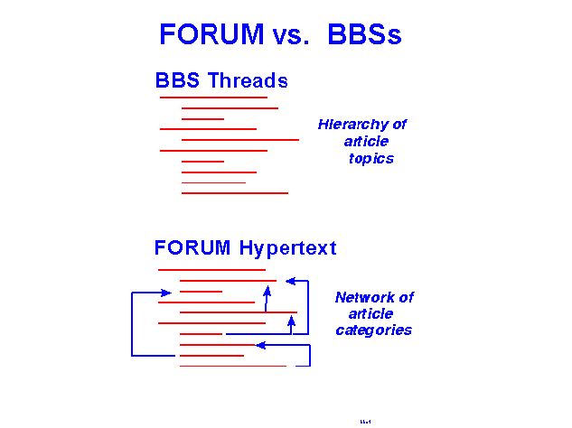
Basic organization of knowledge bases in a hypertext computer conferencing system. Information is not only classified as in bulletin boards, but a variety of nonlinear contextual relationships can be produced by hypertext links. Unlike electronic bulletin boards, the user is not constrained to the outline hierarchy of topics.
A bulletin board could become quite limiting if the logic structure were more complex. Note also that in this simple logic structure, there is no way to create other contextual relationships that extend beyond the outline of topics and subtopics.
But the biggest problem with this conferencing format is that the typical form in which it is implemented is the threaded-topic discussion in which notes are attached to other notes. The popular conferencing systems do not allow attaching notes to specific, in-context, places within a document. Those who have used the World Wide Web know how valuable it is to have hypertext-linked documents that can be launched from specific key words or character strings at various places within a document. Unfortunately, most conferencing systems do not support have this feature. One exception is the software that we have developed, called FORUM (see http://www.ForumInc.com).

Hypertext-based Conferencing
FORUM allows information items to be related to each other with hypertext links that break free from the rigid hierarchy of the BBS (Fig. 1 bottom, Fig. 2). In addition to linking documents to documents, FORUM users can link documents to any character string in a document. FORUM also allows the teacher to specify in advance the linking relationships, thus creating a logic structure that mediates the group's efforts to produce the required deliverables. In Fig. 2 and elsewhere, the block diagrams show the categories of links available in a given conference, and the arrows show the linking relationships. Items with double borders are "community" documents that can accept input from everyone in the group.
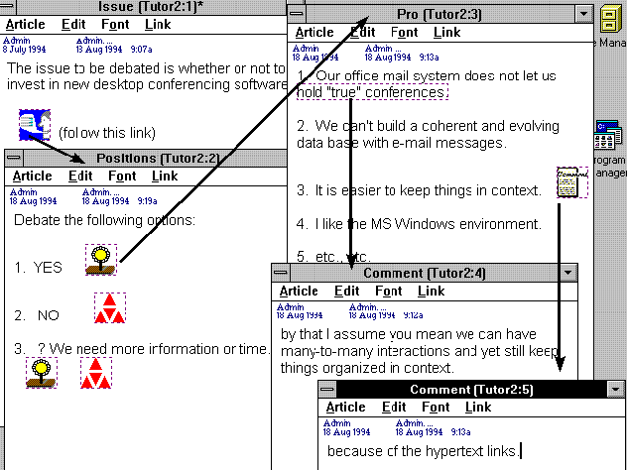
Figure 2. Illustration of in-context hypertext links in the FORUM conferencing system, wherein documents can be linked to other documents or even to specified character strings. FORUM also provides a feature for specifying what can be linked to what, creating a logic structure that guides and directs the evolution of a knowledge base. A given knowledge base may employ multiple logic structures for different purposes. Note that "Position" links from the Issue" article, and the "Pro" arguments link from Positions. Linked "Comments" are launched from an icon anchor and a character string.
Since our experience has been with education and training, we will illustrate our theme by showing how learner groups can benefit from computer conferences that are organized around logic structures. But it is useful to bear in mind that the same principles apply to corporate and institutional activities where information bases are created and used by such work teams as task forces, planning groups, proposal preparation teams, product development teams, sales staff, and quality circles.
We present two example scenarios:
- how to debate applications or "take-home-lessons", and
- how to stimulate "insight."
Debate on Applications or Take-home Lesson (Fig. 3). This exercise has two deliverables. One of these is an Application or Take-Home Lessons list, where each person in a group posts into a community document (shown in double border) those items of fact or concept that seem to be valid applications or take-home lessons of the presented information. Group members debate each item of the list in terms of whether it is optimally worded and whether in fact it is a valid application or "take-home lesson." To the various statements of support and opposition, participants post comments, questions, answers, and raise any issues that emerge from the analysis. Note that participants can attach Issues, Comments, or Questions to both Agree and Disagree arguments. Comments can also be attached to Issues and Questions. Questions can be raised about Comments and Issues. If the software supports it, these relationships can be created by hypertext links. Students find it quite easy to create appropriately linked input in FORUM, because they simply pull down a Link menu that shows them the available choices for the given document that they are reading. A mouse click on the link choice opens a new document for input. When the new document is closed, the link is automatically created. No computer coding is performed by the student.
Figure 3. Example of a hypertext logic structure for getting a user group to create an analyses of an information set in terms of the "take-home lessons" or specific applications of interest to the group.
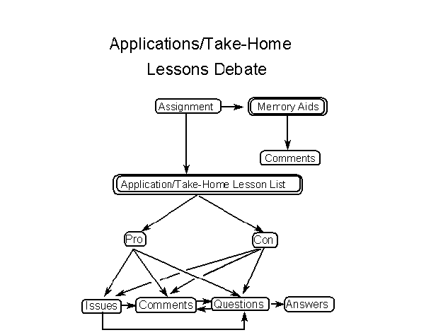
The diagram also shows a Memory Aids community document, in which each participant individually contributes ideas to help everyone remember the applications or take-home lessons. These aids can include things like mental images, drawings, rhymes, riddles, jingles, alliterations, metaphors, analogies, or other mnemonic devices. Our experience thus far indicates that students are not very adept at this sort of thing. We now realise that the teacher needs to provide example mnemonics.
Stimulating Insight (Fig. 4). This approach requires groups to produce a set of three deliverable products. One product is a "Basic Concept List." The intent here is to get students to focus on the principles (not facts!). To do this, they must integrate the facts and think actively and creatively to synthesise these facts into their underlying principles. Students contribute individual suggestions to a group document, and then submit issues, comments, or questions about each of the suggestions. A Group Editor then consolidates the discussion into a final list of concepts.
Figure 4. Example of a hypertext logic structure for getting a user group to discern the central concepts and provide insights from an information set.
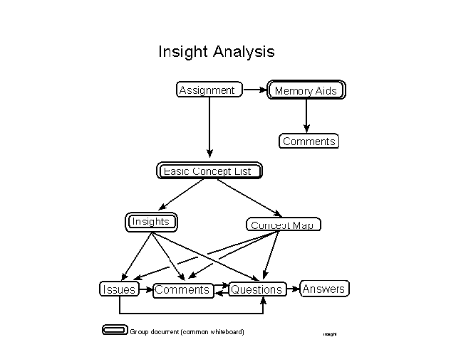
Perhaps the most important part of this logic structure is the requirement to synthesise and think creatively, to produce insights. Students frequently ask "What's an insight?" We have found it helpful to define insight for the students as any thought involving:
Illustration/example
Clarification
Implication/issue
Ramification
Application
Not surprisingly, students (and even teachers) have difficulty in generating insights. We have noticed, however, that students gradually learn from each other what constitutes good insight, and they get progressively better at it as the course progresses.
The second product is a "Concept Map," which shows how the principles inter-relate. The map is constructed from the Concept List by a "Map Editor," who is subject to suggested revisions from the rest of the group to produce a final Concept Map.
The third deliverable is an "Insight Paper," which is a collection of insights provided by each member of the group The collection of insights is analysed via issues, comments, questions, and answers on particular points generated. An "Insight Editor" consolidates the discussion into the final Insight Paper. Any new issues that arise can be separately debated, by having students stake out a position on the issue, present arguments, pro and con, and critique the arguments.
As in the first scenario, the logic diagram shows a Memory Aids document.
An alternative modification of this insight exercise is to require each group member to submit, independently from others in the group, a list of 2-4 provocative questions that arises from a critical analysis of the reading material. Each student would also be obliged to submit what he/she thinks is the best answer to each question. Then, each group member critiques both the questions and the answers of each of the other students. The "Insight Editor" member of the group then incorporates the most meaningful critique comments into a consolidated, edited list of questions and answers about the reading assignment. One of us (WRK) found that his most intellectually stimulating course in graduate school was conducted that way. But the course was taught in the old days without computer conferencing, and the logistics of handing out Xeroxed copies of all questions, answers, and critiques was onerously cumbersome. To help students appreciate how computer conferencing makes this process so seamless and easy, we suggest that teachers try the first week of such a class using hard-copy distribution.
As with memory aids and insights, many students at first have difficulty in constructing provocative questions. But they improve rapidly from observing how others go about this task.

Collaborative Learning

Collaborative Learning Theory
Collaboration requires an active sharing of information and intellectual resources among the students in a group. To be effective, student groups must be inter-dependent. That is, grade incentives are needed that make it clear that some significant portion of the work will receive a group grade. Of course group grades can be a disincentive, if students do not participate equally. In traditional classroom settings, time and distance obstacles commonly prevent true collaboration outside of class. Computer conferencing solves those problems, because all students have equal access to the group's work and are not hindered by schedule constraints.
Team building is central to effective group work. Not only is a cooperative attitude required, but group members must be aware of their group processes and make necessary adjustments (Constantine, 1993; Phillips and Elledge, 1989). A huge literature exists on effective operation of quality circles in corporate environments, and the idea of collaborative learning teams in computer conferencing environments is certainly not new (Kaye, 1991). To build an effective team, each member of the group should have a specified role in achieving the group mission. In a training or education environment based on collaborative learning theory, one of the central tenets is for group members to have specified roles (Johnson et al. 1991). Moreover, it is considered wise to change roles periodically, so that learners gain experience in the various team roles and so that weaknesses and strengths in a given role are averaged out over the course term.
Learners need to have well-defined roles in order to know exactly what is expected of them. One set of roles, for example, that could be used for the Insight Exercise given in Fig. 4 is:
- Leader -- this person, who is also one of the learners, is responsible for the group process, making certain that every member is doing what needs to be done, when it needs to be done, and with the level of quality that the group can accept. More specifically, the Leader is obliged to make "comments" on all documents in their draft stages while the final group-product is evolving.
- Concept List Editor -- this learner's task is to edit, consolidate, and refine the collection of principles that each member submits individually. This Editor is obliged to consider carefully the critiques and suggestions of each member to produce a final product that will win the best possible grade from the teacher.
- Concept Map Editor -- this learner's task is to construct a concept map of the principles provided by the others. This Editor is obliged to follow the dictates prescribed in the List of Principles, showing what they are and how they are functionally related to each other.
- Insight-Paper Editor -- this learner's task is to edit, consolidate, and refine the collection of questions/answers that each member submits individually. This Editor is obliged to consider carefully the critiques and suggestions of each member to produce a final product that will win the best possible grade from the teacher.
- Researcher(s) -- this learner is obliged to help the Editors find needed clarification and information about the assignment. This typically will involve some library work. The researcher may also have the largest obligation to critique all deliverable documents as they are evolving.
- Quizzer (optional) -- this learner would quiz each group member to assure the best possible group grade if a random-draw examination were given over the assignment.

Schedule Considerations
The teacher will want to set deadlines for certain activities. Our experiences show that the whole process breaks down without tightly enforced deadlines. As the attached diagrams indicate, there is a prescribed logical flow pattern for the various documents, commentary, etc. Teachers can use the logic diagram to set deadlines for specific responses to a reading assignment, for example. For the Insight Exercise of Fig. 4, for example, at 8 AM on Monday, the teacher might announce the assignment and any instructions or related information. By Tuesday (perhaps noon or 5 PM), every learner is expected to have read the assignment and to have posted what he/she thinks are the essential concepts illustrated in the assignment. By Wednesday (noon or 5 PM), the Map Editor must post a draft concept map. By Thursday (8 AM), each learner must have posted a specified number (2-4) of insights. Between Tuesday and Saturday, each group member is required to post constructive comments, questions, and answers, and to raise issues that will enhance the quality and rigour of the Concept List, Concept Map, and Insight Paper, so that the respective editors of those documents can produce a final product by Monday morning of the next week.

Grading
A central tenet of Collaborative Learning is that each learner is responsible not only for his/her own learning but also for the learning of everyone in the group. Thus, a significant part of the group activity must be given a group grade. We suggest a group grade for each deliverable from the group. In the introductory neuroscience course, we also found it very useful for everybody take the exams with a random drawing to determine whose paper was to serve as the group grade. The quizzer's job is to make certain that every member of the group can perform well on the examination.
Exceptional students should not feel penalised by performance of lesser talented and/or motivated members of the group. Moreover, poor and/or lazy students should not be rewarded for work done by others. Thus, we suggest that an additional grade factor be incorporated to reflect the relative contributions of each group member. This can include the teacher's estimation of each member's contribution to a given assignment. In a computer conference, the teacher can - and should - monitor what each student is contributing to the group process. More important perhaps is the need to let the students themselves judge each other in terms of how effective each was in the group process. An effective way to do this is to require each student at the end of an assignment to rank each of the other students, on a scale of 0 to 10, in terms of how effective the other students were in contributing to the group's deliverable products. No ties should be allowed. Perhaps other constraints can increase the meaningfulness of this ranking. For example, the teacher might specify that the spread of scores must extend as low as 3 or 4. This approach sensitises each group member to the obligation to shoulder individual responsibility and to self-evaluate in terms of the contributions to others. Ranking is also specifically designed to reward stellar performance.

Conclusion
Group learning can be a powerful educational experience, whether in distance or on-site education. However, group learning is often trivialised by the threaded-topic discussion format that is typically used in computer conference systems. Teachers can lead a group to raise the intellectual level of group discourse by requiring student groups to produce tangible work products (not just opinion comments) and by creating a logical structure to achieve this end. Secondly, the teacher's efforts can be leveraged by promoting interdependent student teams in which students help each other to produce the academic deliverables.

References
Brooks, J. G. (1993). In search of understanding: the case for constructivist classrooms. Alexandria, Va.: Association for Supervision and Curriculum Development.
Constantine, Larry. (1993). People - ware. Having it all. Software Development. September, p. 94-96.
Damon, W. (1984). Peer education: the untapped potential. Appl. Develop. Psychol. 5, 331-343.
Duffy, T. M., and Jonasson, D. H. (1992). Constructivism and the technology of instruction: a conversation. Hillsdale, N. J.: Lawrence Erlbaum Associates.
Gabbert, B., Johnson, D. W., and Johnson, R. (1986). Cooperative learning, group-to-individual transfer, process gain, and the acquisition of cognitive reasoning strategies. J. Psychol. 120, 265-278.
Johnson, D. W., and Johnson, R. T. (1989). Cooperation and competition: Theory and research. Edina, MN: Interaction Book Co.
Johnson, D. W., Johns, R. T., and Smith, K. A. (1991). Cooperative learning. Increasing college faculty instructional productivity. Washington, D. C.: ASHE-ERIC Higher Education Reports. Report #4. The George Washington University.
Kadel, S., and Keehner, J. A. (1994). Collaborative learning. A sourcebook for higher education, Vol. II. University Park, Pa.: National Center of Postsecondary Teaching, Learning, and Assessment.
Kaye, A. R. (1991). Collaborative learning through computer conferencing. The Najaden Papers. Berlin: Springer-Verlag.
Klemm, W. R. (1994). Using a formal collaborative learning paradigm for veterinary medical education. J. Vet. Med. Ed. 21, 2-6.
Phillips, S. L., and Elledge, R. L. (1989). The team-building source book. San Diego: University Associates.
Tobin, K. G. (1993). The practice of constructivism in science education. Washington, D. C.: American Associate for the Advancement of Science.
Webb, N. M. (1982). Student interaction and learning in small groups. Rev. of Educ. Research. 52, 421-445.

Return to Contents Page

Published by the University of Southern Queensland

