The Best Performance Determinant

What's the best performance indicator of your car's power/weight?
By Dennis Jensen
www.autoweb.com.au
A while ago ("Power versus Torque - Part 1") we discussed the issue of power and torque, and whether the power/weight or torque/weight ratio is the best way of determining a car's performance potential (without knowing any further details, anyway!). It was determined that power/weight ratio was the best measure, but even knowing this, there are still some problems that come to light when magazine performance figures are delved into.

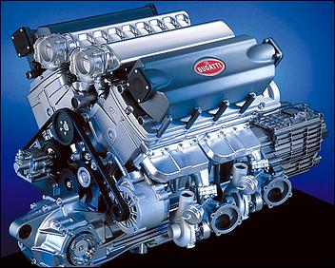
One reason for the confusion is that there are at least four performance measurements commonly used: 0-100 km/h, standing quarter mile elapsed time, speed at the end of the standing quarter, and - once upon a time but not very often now - top speed. So, which is the best measure of performance when yakking to your mates at the bar? Is that quick 0-100 km/h time a good measure? What about those oft-quoted standing quarter mile (400m) times? Or is it perhaps the speed at the end of the quarter that best determines the total vehicle performance?
And, is it possible to reverse the data, so that you can work out your car's peak power (or torque) from any or all of these performance figures? For example, if you know the 0-100 time and the car's mass, can you say with authority how much power you've got?
In order to analyse this, the performance figures of 29 cars were obtained from magazine tests - the cars ranged from a Ford Laser to a Ruf Porsche. These values were then graphed, and a power regression (see breakout box) was carried out to determine the line of best fit through all of the points. A special value (called R² - again see the breakout!) was then determined to see just how well the data fitted the relationship we'd found.
Clearly, the better the performance measurement, the better the 'line of fit' should be.

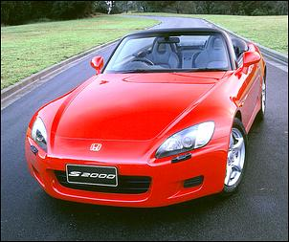
To check the validity, we compared the power/weight and torque/weight figures of two very different cars against their actual measured performance.
The first car was the low power but very torquey old Ford 4.1 Cortina - 1220kg, 288Nm and 92kW. The Cortina did 0-100 in 10.0 seconds, the quarter in about 17.4, flashing over the finishing line at 128 km/h.
The other extreme was the Honda S2000 (176kW, 208Nm, 1350kg). This does 0-100 in about 6.6 seconds, the quarter in about 14.8, finishing at about 155 km/h.
So without further ado, let's have a look at the analysis - which performance index is best?

0-100 km/h

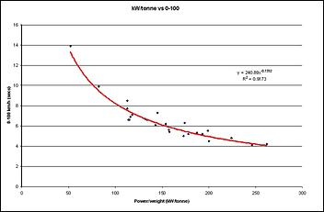
In terms of power/weight, the line match appears to be a fairly good fit, with an R² value of 0.9173. Hmm - that's good enough to start making some predictions of power from the 0-100 km/h time....

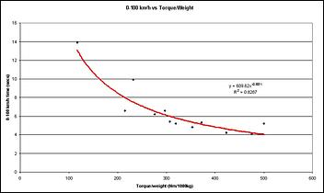
But what about comparing 0-100 times with the torque/weight ratio? This is not as good, with an R² value of 0.8287.
OK, so let's work backwards, comparing the actual 0-100 time of the two cars with that which we could calculate from the lines of best fit.

 | Cortina | S2000
Actual 0-100 time | 10.0 | 6.6
0-100 calculated from power/weight | 10.1 | 6.8
0-100 calculated from torque/weight | 7.4 | 10.5

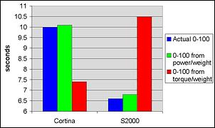
So we got pretty close for both the old Cortina and the Honda S2000. And as we said last time, the torque/weight ratio is not such a good predictor of performance.
OK, but the 0-100 km/h time in some cars is achieved in just the first two gears - and a bad launch can make a diabolical difference to the result. Add to that the fact that a four-wheel drive hi-po car can shave up to a second off the 0-100 by a mind-boggling launch, and you start to wonder how good even the power/weight predictor would be on a variety of cars.
So what about the standing quarter mile?

Standing Quarter Mile

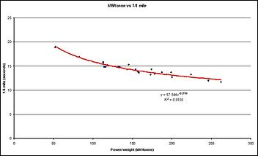
Here is the relationship for power/weight versus the standing quarter mile time and...

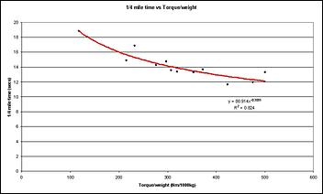
...here it is for torque/weight.
Using our graphed relationship, once again the power/weight ratio gives a better fit than the torque/weight ratio - the R² values are respectively 0.9155 and 0.824.

 | Cortina | S2000
¼ mile actual | 17.4 | 14.8
¼ mile calculated from power/weight | 17.3 | 14.8
¼ mile calculated from torque/weight | 15.2 | 17.4

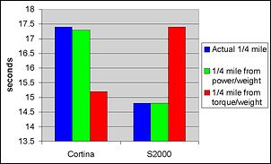
And wow - close, isn't it! We're out by only 1/10th of one second for both cars - and after all, typically you get at least that variation when you're running quarter mile performance times. Hey, maybe we're onto something here...
But again, what if you have a bad launch, or do a gear change that's just slightly slow?
As you'll see, in fact it is the last performance measurement which then gives the best results - the speed that the car is travelling at when it flashed past the quarter mile timing lights.

Quarter Mile Terminal Speed

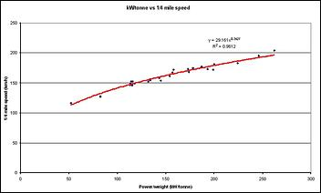
Looking at the quarter mile terminal speed and comparing it with the car's power/weight ratio gives this result. With an R² value of 0.9612, quarter mile terminal speed shows the closest relationship with power/weight of any performance measurement.

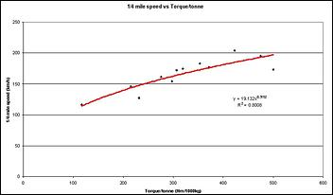
Torque/weight has a poorer R² value of 0.8008 - clearly, the torque/weight ratio regression does not fit very well with the data.

 | Cortina | S2000
¼ mile speed actual | 128 | 155
¼ mile speed calculated from power/weight | 128 | 155
¼ mile speed calculated from torque/weight | 149 | 127

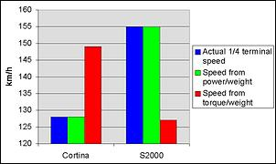
Hey - with power/weight versus terminal speed, we hit the nail right on the head! Predicted and actual speeds at the end of the quarter are dead-on! Of the two approaches, again, the power/weight is a far better predictor of performance than torque/weight - but we kinda guessed by this stage that'd be the case anyway...

Conclusions
So it can be seen that torque/weight is a very bad performance indicator, and power/weight is actually very good.

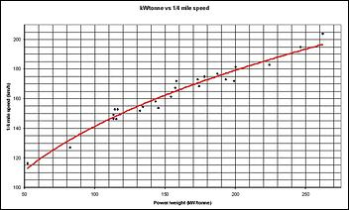
Given the R² values, it can furthermore be seen that the best single indicator of performance in a pub brag is the speed at the end of the quarter. Other figures, particularly the 0-100 time, are very dependent on launch technique and gearing (for example, the Falcon XR6 does not have a great 0-100 time due to the necessity to have a shift from 2nd to 3rd gears prior to completion of the run). The finishing speeds at the end of the quarter, however, are remarkably tolerant of things like bad shifts and bad launches. The quarter time, although a little more forgiving than the 0-100 time, is still not as "idiot proof" as the speed at the end of the quarter.
So, what are you waiting for? Get down to your friendly neighbourhood dragstrip and do a run, and have a look at your finishing speed!

What Analysis?

There are many forms of regression analysis that can be carried out mathematically. The simplest of these is called a linear regression. Basically, it takes all of the data points from the graph, and "fits" a straight line to the data. The method uses what is called the "least squares" method, which effectively totals up the square of the distances from each point to the straight line. The line of best fit is where the sum of these "squares" is minimised.
Clearly, though, for data of the type that we have here, a straight-line equation does not well represent the data, and an equation somewhat similar to some quadratic equations would best fit it. This is called a power law regression, and fits a line to the data with some exponent to the variable (for example, y = x²), where x is the variable and 2 is the exponent. This allows a better fit to the data.
In statistics, there is an R-factor, which is called the correlation coefficient. Basically, it gives a number that indicates how well the selected line fits the data. The R² in fact gives the percentage of the that data fits. So, an R² value of 0.95 means that 95% of the data can be completely explained by the relationship (or equation). The other 5% is due to other factors (in our case, factors such as launch technique, gearing etc). So, the higher the R² value, the better the equation fits the data, and as can be seen for our examples, the speed at the end of the quarter mile is the best predictor of power/weight (and vice versa!).

